**Philippine Air Force – Financial Claim Monitoring System**

Domalanta, Kemp A.

Bugais, Lady Kim M.

Dumandal, Krisa Joy O.

*SS101*

**USE CASE DIAGRAM**

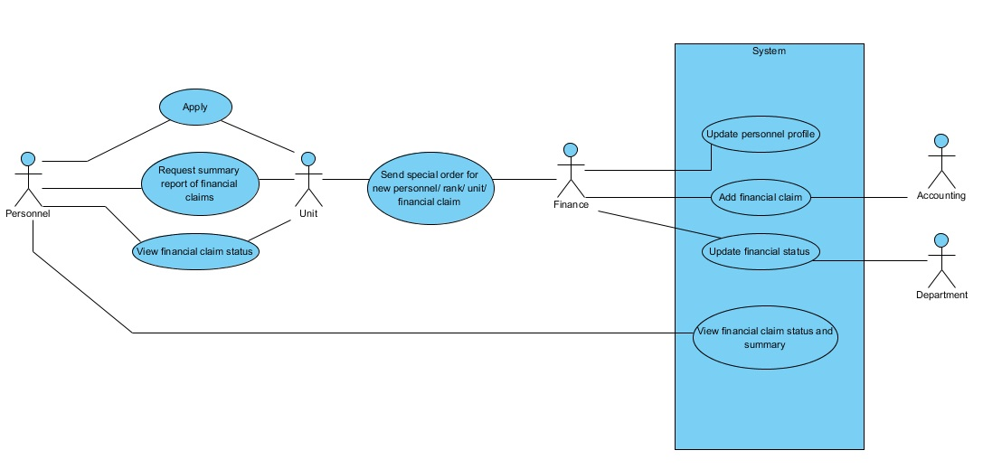

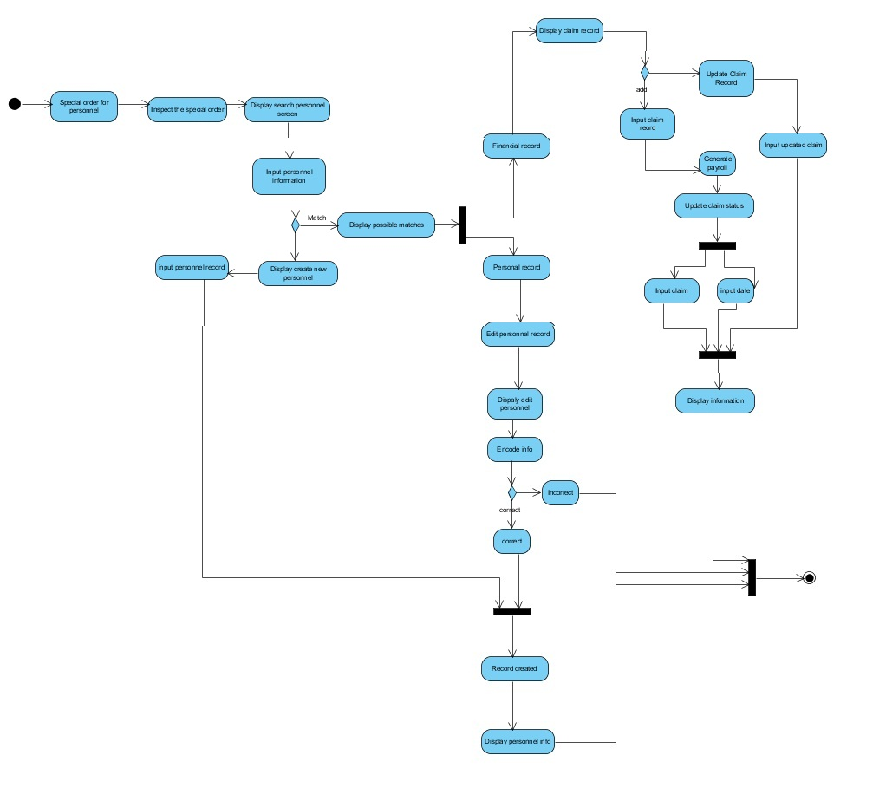

**ACTIVITY DIAGRAM**

**CLASS DIAGRAM**

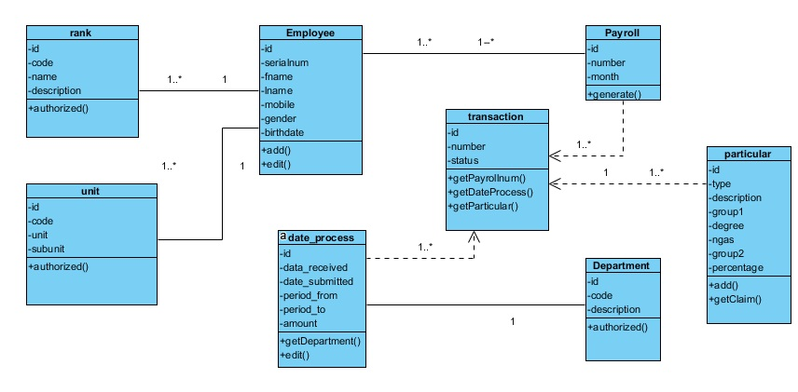

**STATE DIAGRAM**

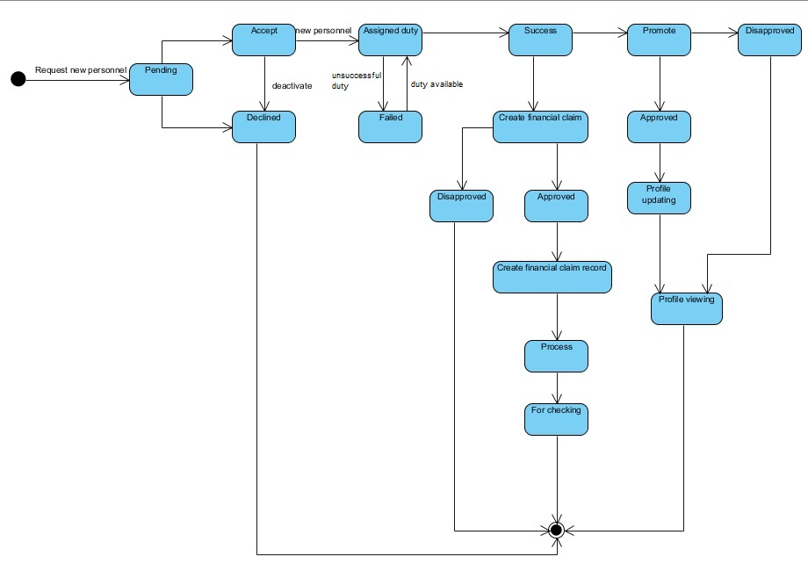

**COMPONENT DIAGRAM**

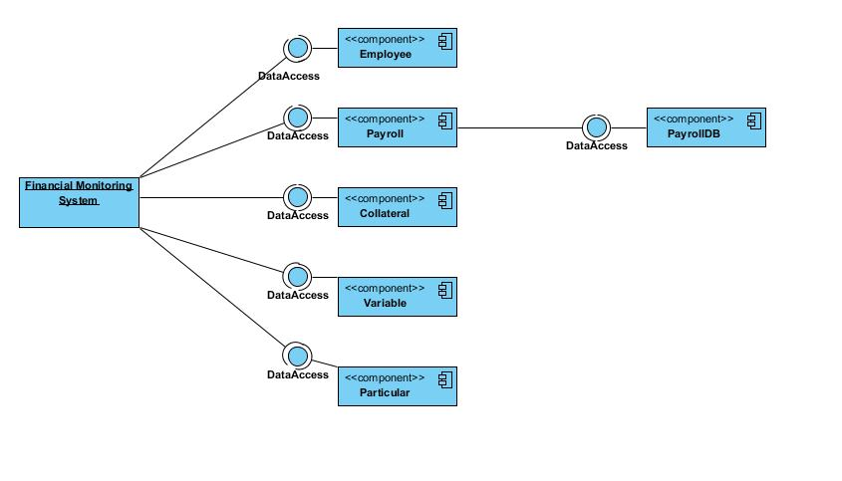

**PACKAGE DIAGRAM**

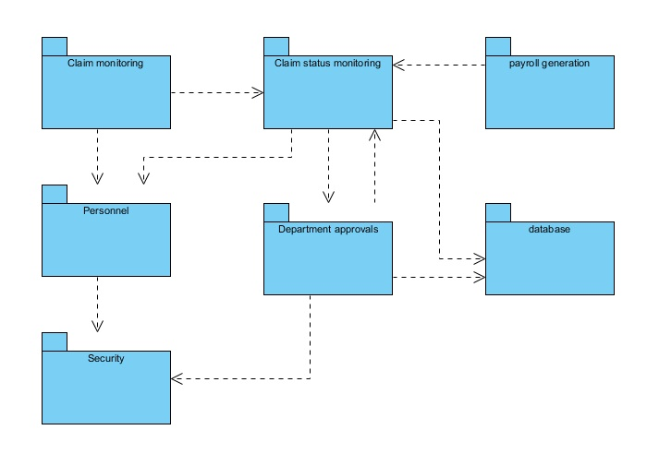

**COMPOSITE STRUCTURE DIAGRAM**

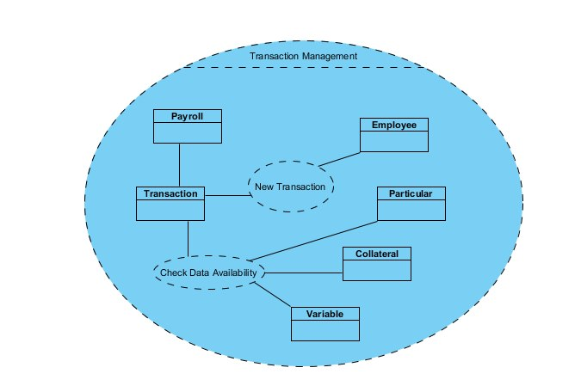

**DEPLOYMENT DIAGRAM**

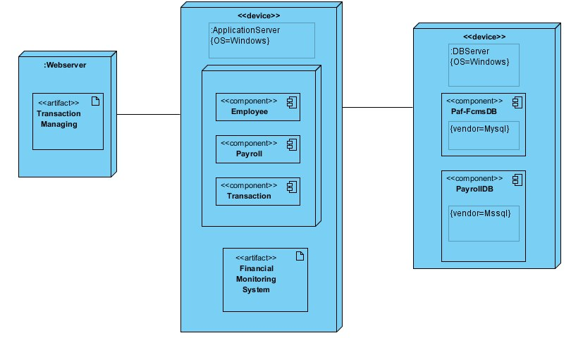

**INTERACTION DIAGRAM**

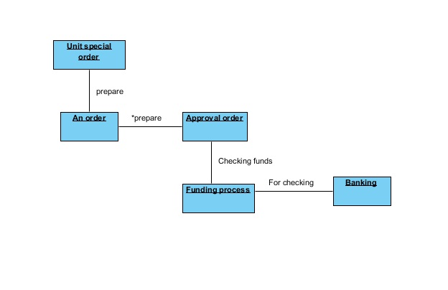

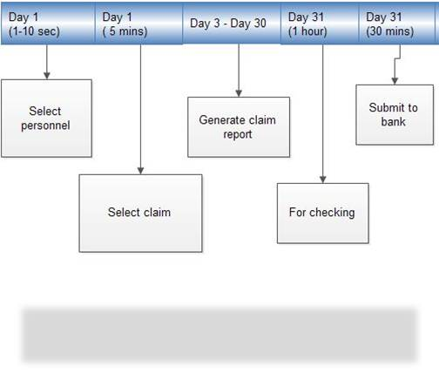**TIMING DIAGRAM**

**INTERACTION OVERVIEW DIAGRAM**

